PLAY Project Video Review Form | 
Child’s Name: Click or tap here to enter text. | Child’s DOB: Click or tap here to enter text.
Visit Date (s): Click or tap here to enter text. | Visit # (s): Click or tap here to enter text.
PLAY Consultant: Click or tap here to enter text. | Frequency of Visits: Click or tap here to enter text.
Video Review Form
- Use bullets to make suggestions for key observations
- Give 3-5 Suggestions per 3-5 minutes of video
- Use bolding to highlight techniques, methods, principles & key points
Date/Activity/Player | Time | Observations & Suggestions:
PLAY Plan
Main Points
“Keys to the Case: How to help the child move up”

- Click or tap here to enter text.
- Click or tap here to enter text.
- Click or tap here to enter text.
Comfort Zone (CZ)
Include ALL CZ, Not only seen on video

Definition of Comfort Zone: When a child “tunes you out” and appears to be in their “own world”, this is when they are going into their comfort zone. When the child is in their comfort zone they are dysregulated and not engaged in the interaction.

Your child’s comfort zone activities include: Click or tap here to enter text.

Sensory Motor Profile (SMP)
The Sensory Motor Profile (SMP) refers to the unique way that a child experiences
the world through the 2-9 primary senses, domains and through movement.

Sensory Over-Reactive - the child demonstrates an exaggerated or heightened response to sensory input.
Sensory Under-Reactive – the child may not respond or may demonstrate a slow response to sensory input.
Sensory Seeking – the child may seek excessive stimulation and/or movement without contentment or satisfaction.

*Suggestions include activities to “do more” or “ less of” to help your child become more regulated*

Emotional Reactivity- A child’s ability to stay calm & alert:

Over-Reactive Under-Reactive
☐Gets upset quickly when told ‘No’ ☐Calms quickly after upset
☐Frustrated easily when expectations not met ☐ Avoids/shuts down rather than get upset
☐Is impulsive and has difficulty staying on task ☐ Ignores loud sounds and chaotic situations
☐Quick to anger ☐Hard to arouse without excess stimulation
☐Hits, bites, lashes out often when upset ☐Seems oblivious to the environment
☐Seems to worry or get anxious easily ☐Few things upset him/her
☐Avoids sensory stimulation
☐Things must be ‘just so’ or gets upset
☐Can’t calm easily once upset

Mixed Reactive
☐Tolerates situations up to a point but then explodes/gets upset
☐Unpredictable emotional response
☐Is ‘moody’
☐Gets overactive at times but can also settle on one activity

Additional Emotional Reactivity Suggestions/Comments:
Click or tap here to enter text.

Visual: A child’s ability to process & interpret the sights around them
Over-Reactive: Under-Reactive:
☐Avoids bright lights/sunshine ☐Enjoys fast paced/brightly colored shows & movies
☐Decreased eye contact ☐Enjoys looking at spinning, moving or shiny objects
☐Seeks visual stimulation such as finger flicking ☐Primarily plays with light up toys
☐Enjoys being in enclosed spaces ☐Becomes preoccupied with the details on toys
☐Dislikes visually busy places (stores, parking lots, etc.) ☐Enjoys looking at patterns & edges

Additional Visual Suggestions/Comments:
Click or tap here to enter text.

Auditory: A child’s ability to process & interpret the sounds around them

Over-Reactive: Under-Reactive:
☐Responds negatively to unexpected or sudden sounds ☐Does not respond to name
☐Has trouble remaining engaged in noisy environments ☐Appears to ignore you or tune out sounds
☐Prefers music and TV to be loud ☐Enjoys repetitive sounds
☐Easily distracted by background sounds ☐Makes noises with mouth, talks to self
(bird chirping, lights humming)

Additional Auditory Suggestions/Comments:
Click or tap here to enter text.

Gustatory: A child’s ability to process & interpret tastes

Over-Reactive: Under-Reactive:
☐Considered a picky eater, limited food choices ☐Prefers extreme temperature food
☐Prefers specific brands, flavors or textures of food ☐Overstuffs mouth with food
☐Dislikes having teeth brushed ☐Frequent drooling
☐Limited oral exploration of toys & other objects as ☐Prefers high flavor foods
an infant/toddler

Additional Gustatory Suggestions/Comments:
Click or tap here to enter text.
Olfactory: A child’s ability to process & interpret smells

Over-Reactive: Under-Reactive:
☐Grimaces or gags in relation to food odors ☐Minimal response to strong smells
☐Avoids places with strong odors ☐Frequently smells non-food items
☐Avoidance of rooms when others are cooking ☐Repeatedly smells objects with strong odors
☐Complaints about smells ☐Repeated smelling of objects & people

Additional Olfactory Suggestions/Comments:
Click or tap here to enter text.
Tactile: A child’s ability to process & interpret touch (the feeling of objects)
Over-Reactive Under-Reactive:
☐Responds negatively to touch ☐Does not notice light touch
☐Avoids getting messy ☐Prefers to be barefoot
☐Sensitive to certain fabrics/tags in clothes ☐Appears not to notice when face/hands are messy
☐Startles easily when touched ☐Decreased awareness of pain or temperature
☐Difficulty sitting or standing close to others ☐May show disinterest in exploring toys/objects
☐Very ticklish
☐Over responsive to physical pain Sensory Seeking:
☐Decreased tolerance for grooming & hygiene ☐Touches & feels everything in sight
activities (brushing/cutting hair, clipping nails) ☐Loves messy play
☐Avoids walking barefoot on different surfaces ☐Seeks movement & vibration
☐Difficulty transitioning between clothing for different seasons ☐Requests tickles & backrubs
☐Frequent touching of preferred objects, carrying objects in hands ☐Frequent oral exploration of non-food objects
☐Demonstrates poor awareness of personal space
or unusual need for touching others
Additional Tactile Suggestions/Comments:
Click or tap here to enter text.
Proprioceptive: A child’s ability to process & interpret input through their muscles & joints
Over-Reactive: Under-Reactive:
☐Prefers sedentary activities, prefers not to move ☐Walks on toes
☐Avoids weight bearing activities (crawling, running, ☐Has low muscle tone hopping, rolling) ☐Clumsy
☐Becomes upset when moved by others ☐Frequently tripping or bumping into things ☐Loves to sleep with thick or heavy blankets
Sensory Seeking: ☐Strong preference for chewy & crunchy foods ☐Walks on toes (loves to chew gum)
☐Bangs head ☐Grinds teeth, bites on fingers, chews clothes
☐Enjoys being hugged tightly
☐Stomps feet while walking
☐Seeks movement activities (bumping, crashing, jumping, etc)
☐Chews on objects

Additional Proprioceptive Suggestions/Comments:
Click or tap here to enter text.
Vestibular: A child’s ability to process & interpret where their body is in space

Over-Reactive Under-Reactive:
☐Dislikes movement activities (swinging, spinning, sliding, etc.) ☐Shows little drive for movement-based activities
☐Does not tolerate being upside down ☐Does not appear to become dizzy when spinning
☐Overly cautious in moving through environment ☐Has low muscle tone
☐Moves stiffly ☐May not sense when falling & does not reach out
☐Dislikes riding in the car to protect self
☐Resistant to laying down for diaper changes Sensory Seeking:
☐Does not like having feet off of the ground ☐Seeks movement activities throughout the day
☐Resistant to tipping head back ☐Enjoys being twirled around
☐Spins self/ Rocks unconsciously
☐Does not appear to become dizzy when spinning
☐Appears to enjoy falling/crashing

Additional Vestibular Suggestions/Comments:
Click or tap here to enter text.
Motor Planning: A child’s ability to plan & sequence motor activity to carry out an idea

Motor Planning Challenges Characterized By:
☐Moves Awkwardly
☐Avoids movement activities, especially new & unfamiliar activities/routines
☐Difficulty with hand-eye coordination
☐Prefers familiar routines & play experiences
☐Appears Clumsy
☐Poor body awareness

Additional Motor Planning Suggestions/Comments:
Click or tap here to enter text.

How to use the FDL chart
- If using Microsoft, right click with your mouse. This will bring up a drop down menu. From that menu please select “Edit Data” then choose “Edit Data in Excel”.
- If using Apple, double click on the chart with your mouse. This will bring up new options in the toolbox at the top of your document. From that menu select “Edit Data in Excel”.
- An Excel sheet will open. Click on correct “Month” at the bottom of the excel file.
- You can begin entering scores (1-4) into the table in Column B. *Reference FDL Report Range Chart for VRF % *
- To exit simply go to the File Tab and click “close”.

Functional Developmental Levels (FDLs)  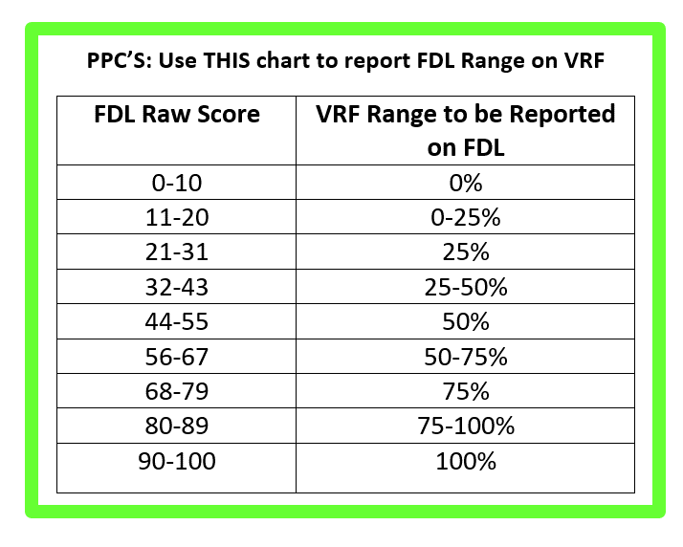 | Your Child’s FDL Profile  Level 1: Self-Regulation and Shared Attention:  - Enter FDL Range %  - Detailed description of child  Level 2: Engagement & Relating:  - Enter FDL Range %  - Detailed description of child  Level 3: Two-Way Intentional Communication:  - Enter FDL Range %  - Detailed description of child  Level 4: Complex Two-Way Communication & Problem Solving:  - Enter FDL Range %  - Detailed description of child  Level 5: Creating & Elaborating Ideas:  - Enter FDL Range %  - Detailed description of child  Level 6: Building Bridges & Ideas, Logical Thinking:  - Enter FDL Range %  - Detailed description of child
Methods  Additional Comments on Methods: | Here are the core Methods of PLAY:  - Read the child's cues and intent  - Slow the pace of play, observing and waiting for the child’s idea  - Follow the child's lead, responding to what the child wants  - Open and close circles of communication (back and forth interactions)  - Build on the child’s interests  Click or tap here to enter text.
Techniques  * It is important to PLAY at the right level for your child. Please refer to your manual to a more detailed description of selected techniques. | FDLs 1-4 Techniques:  ☐Being With ☐Sensory Motor Play  ☐Making Behaviors Purposeful ☐Taffy Pulling  ☐Theme & Variation ☐Salient Language  ☐Onomatopoeia ☐Rhythm & Music  ☐Playful Obstruction ☐Making Them Work  ☐Rewarding & Reinforcing ☐Expectant Waiting  ☐Sense of Humor, Suspense & Surprise ☐Going for Fun  ☐Big, Little & Micro Circles ☐Labeling  ☐Add A Word ☐Asked & Answered  ☐Sequences/ “Little Stories” ☐One & Two Step Directions  ☐Problem Solving  FDL 4-6 Techniques:  ☐Imitative Pretend Play ☐Everything Come Alive  ☐One Thematic Play (FDL 5) ☐Two Thematic Play (FDL 5-6)  ☐Continuous Flow of Circles ☐Speaking “to” & “for” the Child  ☐Appropriate Language ☐Time Concepts  ☐Simple “Wh” Questions: What, Where, Who ☐Complex “Wh” Questions: Why, When  ☐Using Natural Consequences as motivation ☐Completing Tasks  ☐Essays & Summarizing (FDL 6) ☐Practicing Pronouns  ☐Outings ☐Mirroring/Reflecting/Labeling Feelings  ☐Modeling Empathy ☐Negotiating the Relationship (FDL 5-6)  ☐Over-Dramatizing ☐3 Way Modeling: Model, Rehearse, Expect  ☐Social Stories ☐Metacognitive Strategies/Reflective  ☐Theory of Mind Thinking
Additional Technique Suggestions & Comments
Activity Suggestions
FDL 1-2:
Sensory and Cause & Effect

FDL 3-4:
Sequences and Simple Pretend

FDL 5-6:
One & Two Theme Pretend:

Additional Comments & Next Visit

