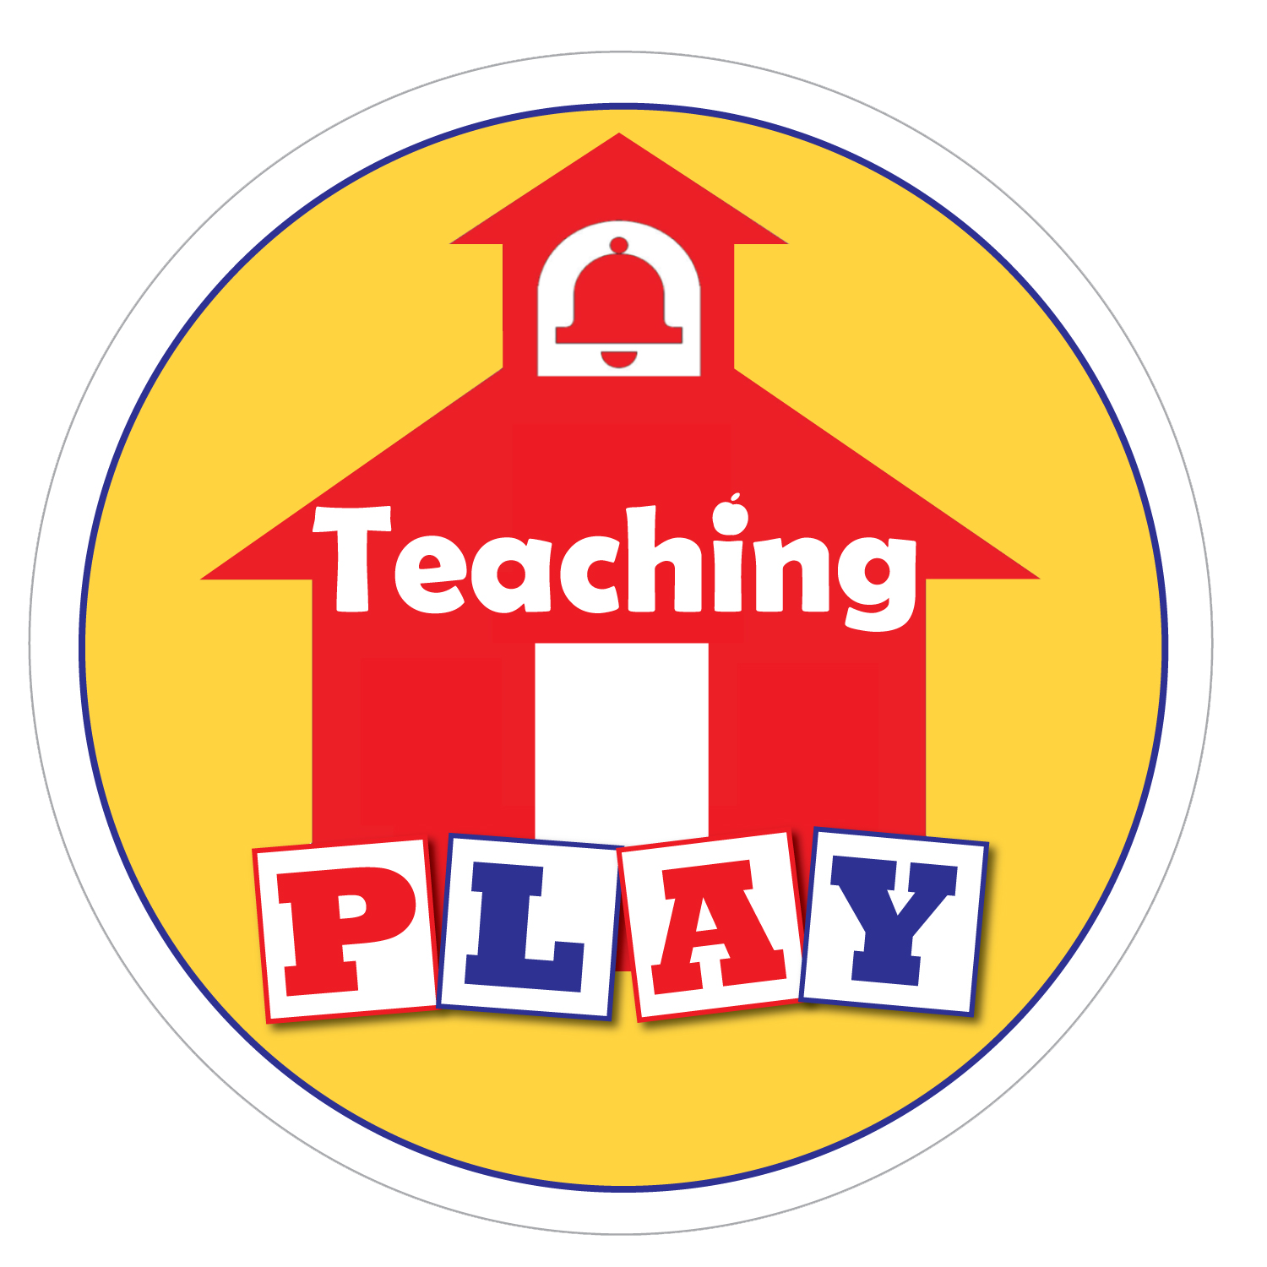
Child Initials: | Date:
Comfort Zones (CZ)

Sensory Motor Profile (SMP)

- Visual Processing:

- Tactile Input:

- Oral:

- Olfactory:

- Auditory:

- Vestibular:

- Proprioceptive:

- Motor Planning:

- Reactivity:

Child Initials: | Date:
Functional Developmental Level (FDL)
Level 1: Regulation and shared attention

Level 2: Engaging in relationships

Level 3: Purposeful interaction (simple games)

Level 4: Organizes chains of interaction and problem solving

Level 5: Uses ideas, words and symbols to convey intentions and feelings

Level 6: Creates logical bridges between ideas

Child Initials: | Date:
Methods
- Read the child's cues and intent
- Slow the pace of play, observing and waiting for the child’s idea
- Follow the child's lead, responding to what the child wants
- Open and close circles of communication (back and forth interactions)
- Build on the child’s interests
Techniques

Activities

