

Supporting Sensory-Sensitive Eaters: Understanding Feeding Through a ﻿Sensory Integration Lens

The ability to eat and feed oneself is essential for survival and health. Beyond nutrition, preparing for, eating, and cleaning up after meals is a meaningful daily activity that supports independence and social connection. Mealtimes can be enjoyable and comforting, but for individuals with sensory processing challenges, they can also feel overwhelming or physically uncomfortable.
﻿
Eating is a complex sensory-motor task that requires the brain to organize and integrate sensory information from multiple systems to produce adaptive responses -such as chewing, swallowing, and staying seated at the table. When sensory processing is inefficient or unbalanced, mealtimes can quickly become stressful.

How the Senses Contribute to Feeding

All our senses play a role in the feeding experience. A child -or adult- may avoid or prefer certain foods based on how their nervous system processes sensory input:
- Touch (Tactile): Dislike of certain textures (mushy, crunchy, mixed), discomfort with messy hands or faces, or not noticing food residue.
- Taste (Gustatory): Heightened sensitivity to bitter, sweet, sour, or salty flavors.
- Smell (Olfactory): Strong reactions to food odors that may seem subtle to others.
- Sight (Visual): Discomfort with certain colors, food combinations, or presentations.
- Sound (Auditory): Distraction or distress from chewing noises or clattering dishes.
- Proprioception (Body Awareness): Difficulty sensing how much pressure to use when holding utensils, biting, or chewing; poor awareness of jaw or tongue movements; slouching or leaning heavily on the table.
- Vestibular (Balance and Movement): Difficulty maintaining an upright posture, sitting still, or stabilizing the head and body while eating.
- Interoception (Internal Body Awareness): Sensitivity to food temperature or mixed internal cues of hunger, fullness, or discomfort.

Some individuals experience sensory modulation difficulties, meaning their nervous system over- or under-responds to sensory input, while others have sensory discrimination challenges, making it harder to interpret and organize sensory information accurately. Both can influence comfort, skill, and motivation during meals.
﻿

  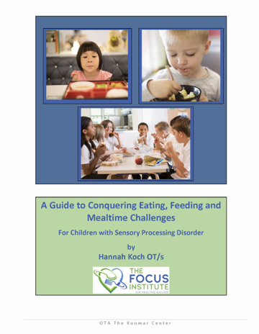
  Free SPD Resources
  A guide to Conquering Eating, Feeding, and Mealtime Challenges plus many more SI related guides are available from our website
  www.thespiralfoundation.org/ind-resources

How Sensory Challenges Affect Feeding

When sensory integration is disrupted, eating can become difficult for many reasons:
- Inefficient oral sensory discrimination can interfere with chewing, swallowing, and drinking skills.
- Sensory defensiveness -as a result of difficulties with modulation- can lead to strong refusals or very limited food preferences related to texture, temperature, color, or brand.
- Poor postural control or body awareness can make sitting at the table and coordinating movements more challenging.
- In some cases -especially for those on the autism spectrum- feeding difficulties may appear behavioral, but underlying sensory modulation or discrimination issues are often significant contributors.

Signs You or Your Child May Be Struggling with Sensory-Based Feeding Challenges

- Gags easily during meals
- Eats a very limited variety of foods
- Refuses to touch or smell new foods
- Gets upset when hands or face are messy
- Struggles to stay seated during meals
- Prefers bland, same-colored, or predictable foods

These responses are not “picky” behaviors. They are adaptive ways of coping with overwhelming or confusing sensory input.

Tips for Supporting Sensory-Sensitive Eaters at Home

- Respect sensory preferences—never force bites or pressure tasting.
- Encourage playful exploration—use food play (painting with yogurt, sorting dry pasta) to build comfort.
- Support regulation before meals—engage in regulating sensory activities like deep pressure, swinging, or heavy work to prepare the body.
- Model enjoyment of a variety of foods without pressure or comparison.
- Create calm, predictable routines—consistent seating, lighting, and timing reduce sensory load.
- Use visual supports (schedules, timers, picture choices) to promote confidence.
- Offer just-right challenges—introduce new foods gradually, in small, low-stress steps, to promote adaptive responses over time.

Small, supported steps can lead to meaningful progress and more positive mealtime experiences.

By viewing feeding through a sensory integration lens, you can better understand your or your child’s experience, support regulation, and encourage adaptive responses. Over time, this helps build confidence, comfort, and a healthier relationship with food—and with mealtimes as a whole.

